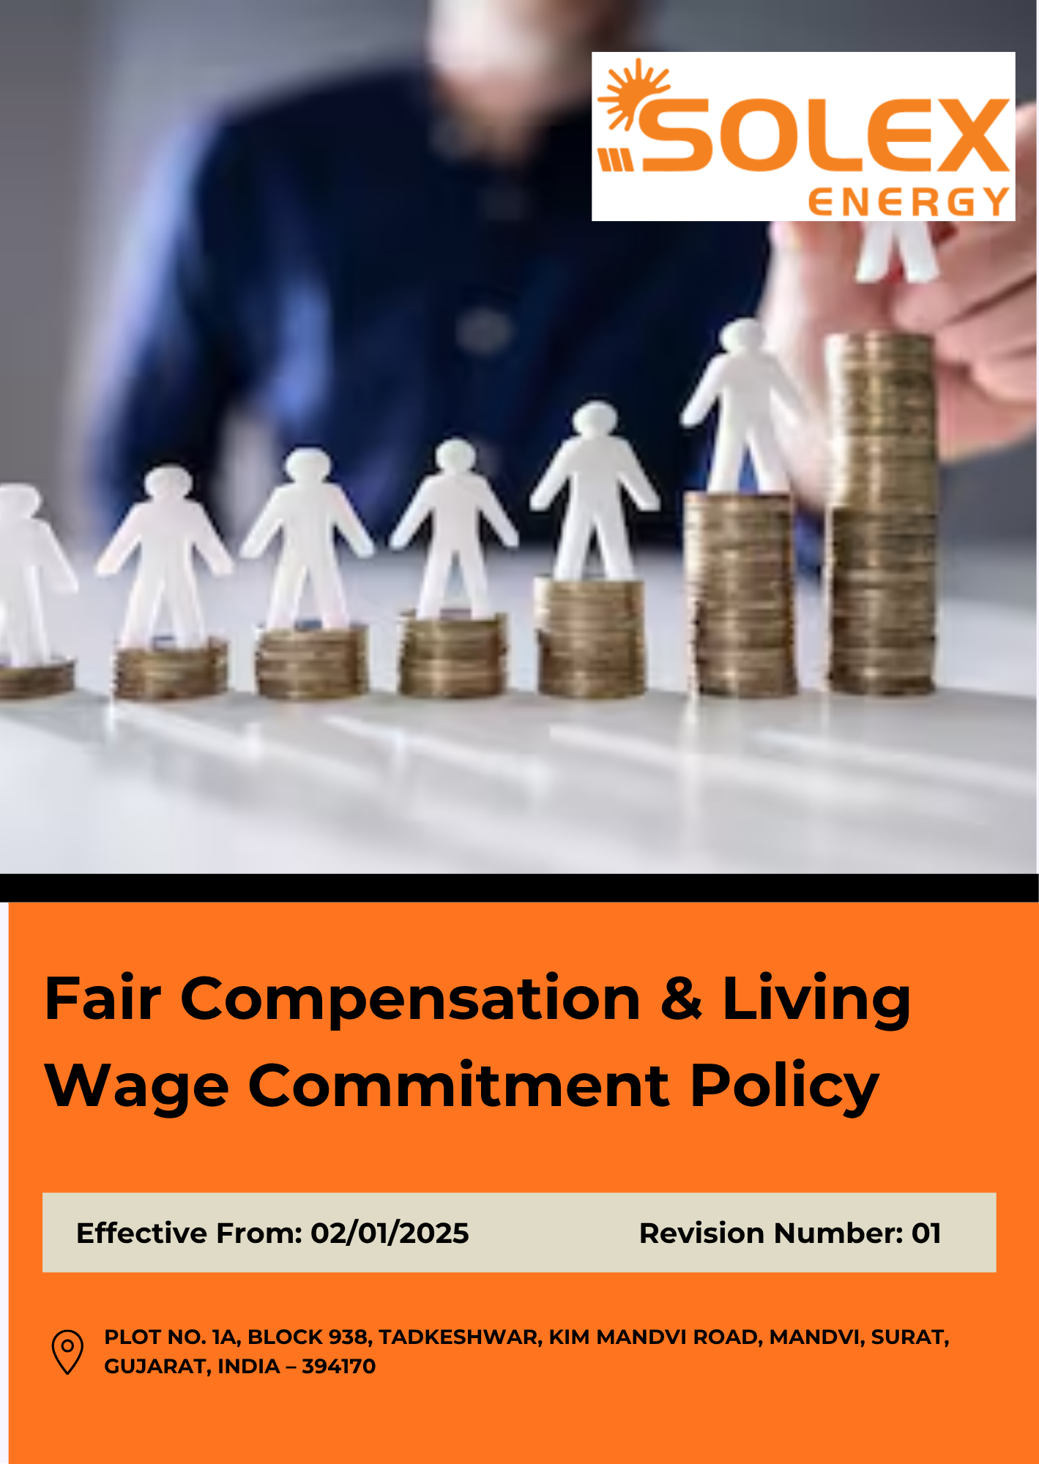
INDEX

1. Purpose & Policy Statement 3
2. Scope 3
3. Fair Compensation Principles 3
4. Determining the Living wage 4
5. Living Wage Goals and Targets 5
6. Contribution to the Sustainable Development Goals (SDGs) 5
7. Governance 6
8. Performance Reporting 7
9. Review Mechanism 8
10. Employee Acknowledgement 9

1. Purpose & Policy Statement
Solex Energy Limited is committed to providing fair, equitable, and responsible compensation to all employees. The Company ensures compliance with applicable wage, salary, benefits, and labour laws while promoting equal pay for equal work and non-discriminatory remuneration practices.
The Company recognizes the importance of living wages in supporting employee well-being and is committed to periodically assessing compensation against relevant living wage benchmarks. Solex Energy Limited strives to maintain transparent compensation practices, address wage gaps where feasible, and provide employees with fair remuneration and applicable benefits.
Through regular monitoring, management oversight, and continuous improvement, the Company seeks to foster a productive, inclusive, and sustainable workplace where employees are compensated fairly for their contributions.

2. Scope
This Policy applies to all Solex Energy Limited operations and covers all employees, including permanent, temporary, contractual, trainee, apprentice, and part-time personnel, irrespective of their position or level within the Company.
The Policy covers matters related to fair compensation and remuneration practices across the Company's operations, including statutory wage compliance, living wage assessments, equal pay for equal work, employee benefits, payroll management, overtime compensation, non-discriminatory remuneration practices, wage transparency, and periodic review of compensation structures to support employee well-being and financial security.
Solex Energy Limited | Block No. 938, Plot No. 1A, Tadkeshwar, Taluka Mandvi, Kim–Mandvi Road, District Surat, Gujarat – 394170, India

3. Fair Compensation Principles
Solex Energy Limited is committed to maintaining fair, equitable, and transparent compensation practices in accordance with applicable national and international labour laws and recognized employment standards. The Company periodically reviews its compensation structure against statutory requirements, industry benchmarks, economic conditions, and recognized living wage methodologies, including the IDH Living Wage Methodology.
The Company strives to ensure that employee wages and benefits meet or exceed legal requirements and progressively align with living wage standards applicable to its operating locations, thereby supporting the financial well-being, dignity, and long-term security of its workforce.

4. Determining the Living wage
Solex Energy Limited follows a systematic approach to determine and assess living wage levels across its operations.
4.1 Identification of Living Wage Benchmarks
The Company identifies relevant living wage benchmarks for each operating location using recognized methodologies, including the IDH Living Wage Methodology and other credible national or international sources, where applicable.
4.2 Assessment of Local Living Costs
The Company evaluates key cost-of-living factors, including food, housing, healthcare, education, transportation, utilities, and other essential household expenses relevant to the local area.
4.3 Review of Economic and Market Conditions
Living wage assessments consider local economic conditions, inflation trends, labour market developments, and industry compensation benchmarks to ensure wage evaluations remain current and relevant.
4.4 Wage Benchmarking and Gap Analysis
Employee compensation is periodically compared against applicable living wage benchmarks and statutory wage requirements to identify potential gaps and opportunities for improvement.
4.5 Management Review and Continuous Improvement
Assessment outcomes are reviewed by management and considered during compensation planning and periodic wage reviews. Where feasible, the Company seeks to progressively address identified wage gaps and strengthen fair compensation practices over time.

5. Living Wage Goals and Targets
Establishes 2023 as the Baseline year for measuring progress and achievements in our initiatives.
- Conduct periodic living wage assessments to evaluate employee compensation against recognized living wage benchmarks and identify areas for improvement.
- Strengthen compensation governance by integrating living wage considerations into remuneration reviews and workforce planning processes.
- Enhance transparency and employee awareness regarding compensation structures, benefits, and living wage commitments through regular communication and engagement initiatives.
- Promote equitable compensation practices by regularly reviewing remuneration structures to support fairness, consistency, and equal pay for equal work.
- Continuously improve employee well-being by assessing and enhancing wage and benefit programs in response to changing economic conditions and workforce needs.
- Assess 100% of employees against applicable living wage benchmarks by Year 2030.
- Maintain 100% compliance with applicable minimum wage and statutory compensation requirements through Year 2030.
- Ensure that 100% of eligible employees receive all applicable statutory benefits and compensation entitlements by Year 2030.
- Conduct living wage gap analyses covering 100% employees at least annually by Year 2030.
- Reduce identified living wage gaps, where applicable, and achieve alignment of at least 95% of assessed employees with relevant living wage benchmarks by Year 2030.

6. Contribution to the Sustainable Development Goals (SDGs)
This Policy contributes to the achievement of the United Nations Sustainable Development Goals (SDGs), particularly SDG 1 (No Poverty), SDG 3 (Good Health and Well-being), SDG 5 (Gender Equality), SDG 8 (Decent Work and Economic Growth), and SDG 10 (Reduced Inequalities), by promoting fair compensation, living wages, equal pay practices, and employee financial well-being.
 |  | 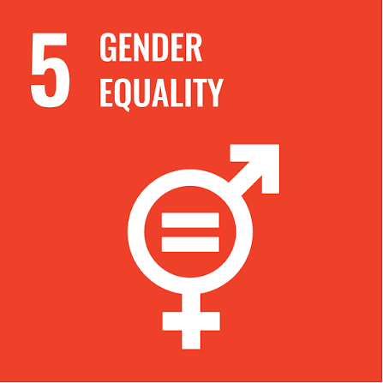 | 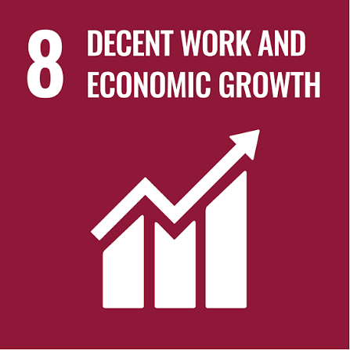 | 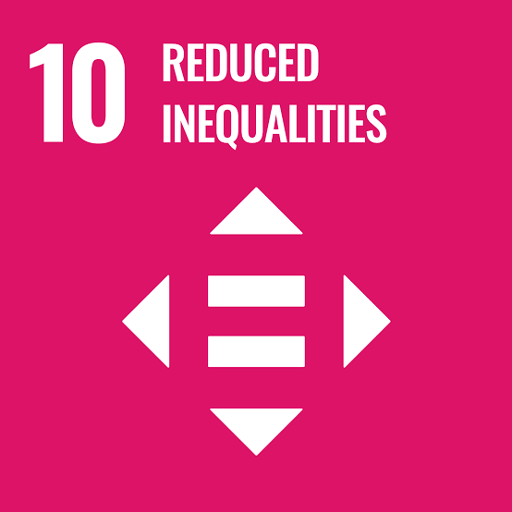

7. Governance
Board of Directors
Provides overall oversight of the Company's fair compensation and living wage practices and reviews relevant performance, risks, and progress against established objectives and targets.
Senior Management
Provides leadership, resources, and accountability for implementing this Policy and ensures that fair compensation and living wage considerations are incorporated into workforce planning, remuneration decisions, and business practices.
Human Resources Manager
Acts as the primary custodian of this Policy and coordinates compensation reviews, living wage assessments, wage-gap analysis, statutory compliance, employee benefits, and related awareness and communication activities. The Human Resources Manager shall also review and update this Policy annually & whenever there are changes in applicable laws, regulations, Company procedures, compensation practices, or other relevant requirements.
Chief Finance Officer
Supports accurate and timely payment of wages, salaries, overtime, and applicable benefits and maintains appropriate payroll records and controls to support compliance with approved compensation structures and statutory requirements.
Department Heads & Supervisors
Support the implementation of fair compensation practices within their areas of responsibility, provide relevant workforce information, and ensure that employees receive applicable wages, benefits, and entitlements in accordance with Company requirements.
Employees and Workers
Comply with applicable Company policies and procedures, provide accurate information required for compensation processes, and raise concerns regarding wages, benefits, or other compensation-related matters through established channels.
The effectiveness of compensation and living wage practices shall be periodically evaluated through wage reviews, living wage assessments, gap analysis, employee feedback, compliance reviews, and relevant performance indicators. Identified gaps and improvement opportunities shall be addressed through appropriate management actions.

8. Performance Reporting
8.1 Wage Compliance Reporting
Solex Energy Limited shall conduct periodic reviews of its wage and compensation practices against applicable legal requirements, living wage benchmarks, and the objectives established under this Policy. Reporting shall cover, as applicable:
- Compliance with statutory minimum wage and compensation requirements.
- Coverage and outcomes of living wage assessments.
- Identified wage gaps and progress towards addressing them.
- Employee feedback and concerns relating to compensation and wage fairness.
- Progress against established fair compensation and living wage targets.
8.2 Internal Review and Audit
Periodic internal reviews or audits shall be conducted to assess the effectiveness of wage management processes and adherence to this Policy. Reviews may include verification of wage calculations, timely payment of wages and benefits, statutory compliance, and implementation of corrective actions.
8.3 Stakeholder Engagement
The Company shall engage, where appropriate, with employees, employee representatives, payroll personnel, and relevant external experts to obtain feedback on compensation practices and living wage assessments. Feedback and concerns shall be considered in periodic policy reviews and improvement initiatives.
8.4 Management Review and Disclosure
Performance results shall be reviewed by management and used to identify corrective actions and opportunities for improvement. Relevant performance information may be communicated through internal reports and, where appropriate, the Company's sustainability or ESG disclosures.

9. Review Mechanism
The Human Resources Manager shall review this Fair Compensation & Living Wage Commitment Policy annually to ensure its continued relevance and effectiveness. The review shall consider living wage assessment results, wage compliance, identified gaps, employee feedback, audit findings, changes in economic conditions, and progress against established targets.
The Policy shall be updated as required to reflect changes in applicable national and international labour laws, regulations, recognized living wage methodologies, Company procedures, compensation practices, or identified risks and improvement opportunities. Significant revisions shall be communicated to relevant employees and stakeholders.
Revision History
Revision No. | Date | Description of Change
0.0 | 02/01/2025 | Initial release of Fair Compensation & Living Wage Commitment Policy
1.0 | 02/01/2026 | Review and update of fair compensation principles, living wage assessment approach, measurable targets, and performance review mechanism

Approved by:

[Name]
Chairman & Managing Director
Solex Energy Limited

10. Employee Acknowledgement
I acknowledge that I have received, read, and understood the Fair Compensation & Living Wage Commitment Policy of Solex Energy Limited. I understand that the Policy establishes the Company's principles and expectations regarding fair, equitable, and transparent compensation, statutory wage compliance, employee benefits, equal pay, and living wage practices.
I understand my responsibility to comply with applicable Company policies and procedures and to raise any concerns relating to wages, benefits, compensation practices, or potential violations through the designated reporting channels.
I understand that the Policy is reviewed periodically and may be updated to reflect changes in applicable laws, regulations, compensation practices, living wage benchmarks, or Company requirements.
By signing below, I confirm my understanding of the Policy and my commitment to support and comply with its applicable requirements.
Employee Name | ______________________________
Employee ID / Department | ______________________________
Acknowledgement Date | ______________________________
Employee Signature | ______________________________

